Allianz Insurance Company
Life Insurance Processing System
Business Requirement Document
V 1.0



 | Prepared By / Last Updated By | Reviewed by | Approved By
Name | Sharmila Banu | Yamuna Pillai | Kumaragurubaran, T
Role
Signature
Date | 20 th Nov 2014

Table of Contents
1.0 Introduction 3
1.1 Purpose of this document 3
1.2 Project Overview 3
1.3 Scope 3
1.3.1 In scope 3
1.3.2 Out Scope 3
1.4 Intended Audience 3
1.5 Constraints, Assumptions and Dependencies 3
1.6 Definition & Acronyms 4
2.0 Organization Architecture 4
3.0 Process Architecture 4
4.0 Business Process Analysis 4
4.1 Current Scenario 4
4.1.1 ‘As-is’ Process Flow 5
4.1.2 Process Flow Details 5
4.2 Proposed Solution 5
4.2.1 ‘To-be’ Processes 6
4.2.2 Process Flow Details 6
5.0 Process Definitions 7
5.1 Business Rules 8
6.0 High Level Business Requirements 8
7.0 Detailed Business Requirements 8
8.0 Business Process to Requirements Traceability 8
9.0 Objective and Expectation Traceability 8
9.1 Business Objective Traceability Matrix 8
10.0 References 9
11.0 Change Log 9

Introduction

Purpose of this document

This document is aimed at

- Providing the necessary inputs to the detailed requirements gathering phase and further on for the SDLC processes.
- This document also serves to establish the traceability between the Business Objectives and the requirements identified in the proposed solution and how they satisfy the stated objectives.
- Provide expectation traceability in terms of the requirements and the user expectation
- Serves as a formal template for documenting the Business Requirements which also includes statutory and regulatory requirements.

Project Overview

Allianz Insurance Company is a leading insurance company in India. It offers various types of Policies for its customers. Due to large amount of data, the insurance company plans to automate it processes. For this purpose it needs to store all the details in different databases like Policy Database, Agent Database, and Customer Database etc. so the main objective of this project is to store the insurance policy details in the database system.

Scope

In scope
- The data should be verified and validated and should be processed for the valid records and reports should be generated out of it.
- The respective modules to be created and tested accordingly to achieve the final result of the business need.

Out Scope
NA

Intended Audience

Cognizant Associate Trainees (CAT).
.

Constraints, Assumptions and Dependencies

Constraints:

- The application should accept the applicant data which are provided by Allianz Insurance Company
- This application will accept and process the data sent on monthly, quarterly and yearly

Assumption:

- The applicant data should be sent to the Allianz Insurance Company only.
- This application will process only the valid customers.

Dependencies and Risk:
- This application should be active for all calendar days. Any outage on the external data system and third party verification system should not impact this application.
- This application should not go down even though if there are no customer’s data to get processed on any calendar days.

Definition & Acronyms
NA

Organization Architecture
Refer to SRD document section 1.2.2 for Organization Architecture.

Process Architecture
The major activities that will be involved in this new application are:-
- Validate the Life insurance Policy details and store the details into Policy database.
- Validate the Agent details and store then details into Agent database.
- Split up the insurance policy file based on the term and sort the file in the order of policy id and policy code.
- The respective error out files will be stored and the necessary cleanup process will be done by the organization bases on the requirement.

Business Process Analysis

Current Scenario

‘As-is’ Process Flow
Allianz Insurance Company offers various types of Policies for its customers. Currently the large amount of data are manually feed into files lot of time are involving in this manual process. For this purpose it needs to store all the details in different databases like Policy Database, Agent Database, Customer Database etc. so that the manual effort will get reduced.

Refer to SRD document section 1.2.5 for Current process flow.

Proposed Solution

Due to large amount of data, the insurance company plans to automate it processes.

‘To-be’ Processes
For this purpose it needs to store all the details in different databases like Policy Database, Agent Database, and Customer Database etc.

The current business need is to create new databases and store the details about Policies and Agents. Whenever a new Policy is introduced the details will be added to Policy Database and when a new agent is registered the details will be added to Agent Database. The details are available in the Insurance Policy File and Agent Detail file respectively.

Refer to SRD document section 1.2.5 for the proposed solution.
The proposed process for Life Insurance policy system is as shown below.

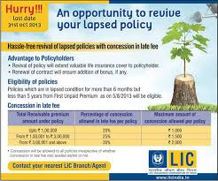   premium details
Policy details Policy holders

History Database load Monthly report

Process Flow Details
The proposed application process flow is as below.
- Create Premium Table and load the below details. Before loading into database, do the basic validations (check for format and mandatory values, numeric check) write the error records into Error file with rejected reason. Error file has same layout of Premium detail file.

For calculating balance amount, refer the Policy amount from Insurance Policy Database.

- Holder Id
- Holder Name
- Policy Code
- Policy Id
- Policy Number
- Policy Amount
- Premium Amount
- Premium Received Date
- Balance Amount
- Next Premium Due Date
- Interest Paid

- Split “Premium Detail” file into different files based on policy Amount. Policies with amount <= 8000 in one file and rest in another file. And sort the file in the order of Holder Id, Policy Id, Holder Name and Premium Amount. This file will be internally referred by the processing Divisions.

- Include the newly added premium detail in Master premium VSAM KSDS file

- Extract the required details and generate a separate report file for the above applicants in the standard report format. Use page break logic. Maximum no: of lines to be displayed in a page are 10.

Note:
  - Master premium VSAM file contains the Details of all premiums.
  - Maintain back up of all the input and output files in GDG File where GDG limit is 7 versions. No need to back up any intermediately output files.


Process Definitions
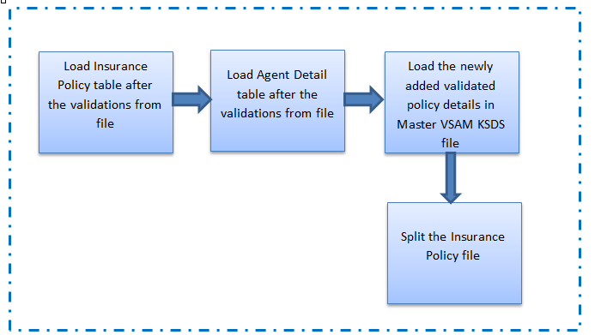

Business Rules

# | Rule Name | Definition
1 | Business Frequency | Monthly, Qly and Yearly
2 | Business data | Only the validated records and the term which is holding the value (MONTHLY/QLY/YEARLY) should be taken into further processing.

High Level Business Requirements

Sno. | Business Requirement ID | Short Description | Description in detail | Interacting Business Processes
1 | BRD08 | Validate the data. | All required basic validations should be performed | Allianz Insurance Company& Verification team.

Detailed Business Requirements
Req. # | Business Requirement | Req. Type * | Priority ** | Originator *** | BR Traced to Business Requirement/ Use case ID
1 | BRD08 | F | 1 | Policy Processing | BRD08

Business Process to Requirements Traceability
Sno. | Business Process | Business Requirement

Objective and Expectation Traceability

Business Objective Traceability Matrix

Business Objective | Business Requirement Number | Priority | Requirement Title | How requirement satisfies objective | Status

Expectation | Priority | Requirement Provider | Where satisfied | How satisfied | Status

References
Proposed Business Flow.

Change Log
Version Number | Changes Made
V1.0.0 | Sharmila Banu
V1.1.0
V1.1.0 | Section No. | Changed By | Effective Date | Changes Effected

